Office Use Only
Start Date: _______ Working: _______ TAFDC: ________ School: _________ Agency: _________________________
Termination Date: _________________
NEW AGE SCHOLARS FAMILY CHILDCARE CENTER
OFFICE: 617 363-6996 CELL: 857 220-7170 FAX: 617 648-5029

Child’s Name: _________________________________________ Age: ________ Address: _________________________ City: _____________ Zip: ____________
Date of Birth: ______________________ City of Birth: _________________
Primary Phone: _______________________ Alternate: ________________________
Mother’s Name: _______________________ Email: ___________________________
Occupation: ___________________________ Hours: ___________________________
Name of School/Employer: _____________________________________________________
School/Employer Address: _____________________________________________________
School Employer Number: _____________________________________________________
Father’s Name: _______________________ Email: ___________________________
Occupation: ___________________________ Hours: ___________________________
Name of School/Employer: _____________________________________________________
School/Employer Address: _____________________________________________________
School Employer Number: _____________________________________________________

Name two relatives/friends who live nearby to contact in case of emergency:

NAME: ______________________ RELATION: _______________________
PHONE: _________________________ ADDRESS: _____________________
NAME: ______________________ RELATION: ________________________
PHONE: _________________________ ADDRESS: _____________________

Please list all brothers and sister living at home with your child:
NAME: BIRTHDAY:
NAME: BIRTHDAY:
NAME: BIRTHDAY:
NAME: BIRTHDAY:

List person(s) to whom New Age Scholars may release your child:

NAME: ______________________ RELATION: _______________________
PHONE: _________________________ ADDRESS: _____________________
NAME: ______________________ RELATION: ________________________
PHONE: _________________________ ADDRESS: _____________________
NAME: ______________________ RELATION: ________________________
PHONE: _________________________ ADDRESS: _____________________

HELP US KNOW YOUR CHILD
Has your child ever attended daycare: YES NO
If so for how long:

What are the most important experiences that you want your child to have in pre-school?
1)

2)

3)

SOCIAL DEVELOPMENT:

Has your child had group experiences with other children? YES NO

With younger children? YES NO

With children their same age? YES NO

With Boys? YES NO With Girls? YES NO

Please give a brief description of your child’s interaction with brothers/sisters
_____________________________________________________________________________
Does your child have any fears such as heights, dogs, thunder, etc.?

Please specify the way in which you comfort or reassure your child at home?

Has your child experienced any serious family situations such as death, divorce, accident, etc.?

What activities does the family do together?

Father with child:

Mother with child:

How does your child behave in a new situation?

What toys and activities does your child enjoy most?

TOYS ACTIVITIES

HEALTH
Does your child have any difficulties with?
VISION YES NO

HEARING YES NO

SPEECH/LANGUAGE | YES | NO
TOILET TRAINING | YES | NO
HEART CONDITION | YES | NO

SEIZURES YES NO

If you answered yes to any of the above, please explain:

Does your child have any allergies? Is your child sensitive to wasp, bees, etc.? YES NO
If yes, to what?

Are they presently taking medication for these allergies?

Do they have medication for this?

Is your child taking any routine medication?

If yes, explain:

PHYSICAL DEVELOPMENT
What was your child's weight at birth?

Was your child full term or premature at birth?

At what age did they sit up?

Is your child left handed or right handed?

Is your child fully toilet trained? YES NO
Can they tie their shoe? YES NO
Can your child color with crayons? YES NO
Write with a pencil? YES NO
Can your child climb up and down stairs? YES NO
Can they walk well? YES NO Can they run well? YES NO Has your child had any serious illness or accident?

If yes, explain:

INTELLECTUAL DEVELOPMENT
Is your child able to do the following?
Say their home address? | YES NO
Say their telephone number? | YES | NO
Recite the letters of the alphabet? | YES | NO
Count from 1 to 10? | YES NO
Write their name? YES NO

Follow Directions? YES NO
Does your child enjoy a story? | YES | NO
Do they enjoy poetry? | YES | NO
Do they enjoy music and singing? | YES | NO
Does your child have any special creative talents, such as art, music, singing, etc?

Can they retell a story to you? | YES | NO
Can you comment about any other abilities or special needs, which might be helpful:

PERSONAL HABITS
What language(s) are spoken at home?

What language(s) does your child use at home?

At what time does your nap at home?

Is there a problem with wetting during nap time?

Please provide a sample of our child's day at home?

EMERGENCY CONSENT FORM
NEW AGE SCHOLARS

I understand that every effort will be made to contact me in the event of an emergency requiring attention for my child
However, if I cannot be reached, I hereby authorize NEW AGE SCHOLARS to transport my child to theHospital and to secure them for the necessary medical treatment, including anesthesia. I also understand that the teachers at the daycare center are trained in the basics of First Aide and I authorize them to give my child First Aide when appropriate.
I can be reached at:
Home Phone: Cell Phone: Work Phone:
Child's Physician/Clinic:
Address: Phone:
Emergency Contacts:
The following relatives/friends should be contacted if I am unavailable in an emergency. I also authorize NEW AGE SCHOLARS to release my child to their custody when I cannot be reached.
Name: Relation:
Phone 1: Phone 2:
Name: Relation:
Phone 1: Phone 2:
Name: Relation:
Phone 1: Phone 2:

Signature of Parent/Guardian Date

Transportation Plan and Authorization
ARRIVAL: | DEPARTURE:
PARENT DROP OFF | PARENT PICK UP
PRIVATE TRANS. | PRIVATE TRANS.
Arranged by Parent | Arranged by Parent
OTHER | OTHER
Drop off time: | Pick up time:
CHILD'S NAME:

Alternate Family/Friend to release my child(ren): Photo ID will be required for release
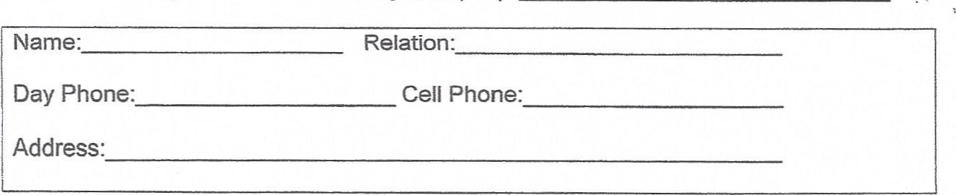
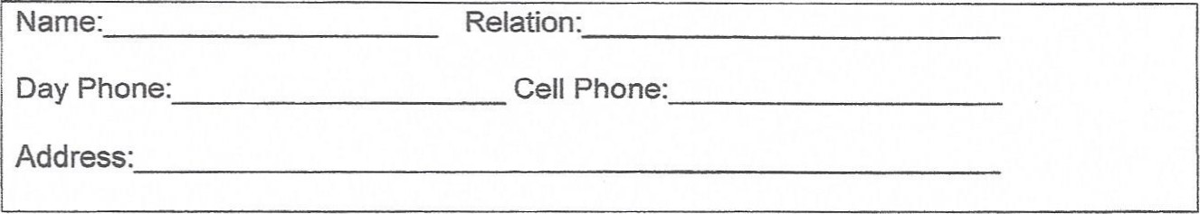
PARENT/GUARDIAN SIGNATURE DATE
*New Age Scholars does not offer transportation services to or from the program. In the event of a field trip, specialized transportation plans will be signed with permission forms.

CHILD IDENTIFICATION FORM
NEW AGE SCHOLARS

Child's Name:
Address:
City, State, Zip:
Home Phone:Business:
Name of Emergency Contact:Phone:
Male/Female:Age:Date of Birth:
Race:BlackWhiteHispanicOther
Color of Hair: Color of Eyes:
Height: Weight:
Distinguishing Marks:
Place Child's Photo Here

Individual Health Care Plan
Check all that apply...
Plan was created by: Plan is maintained by:

Parent
Doctor or Licensed Practitioner
Program's Health Care Consultant
Name of Child: Date:
Name of chronic health care condition and/or health concern:
Description of chronic health care condition and/or concern:
Symptoms:
Medical treatment necessary while at the program or follow up needed
Potential side effects of medication/treatment:
Potential consequences if treatment is not administered:
Name of educators that received training addressing the medical condition and/or concern:
Person who trained the educator (child's Health Care Practitioner, child's parent program 's Health Care Consultant):

Name of Licensed Health Care Practitioner (please print): _____________________ Date: _________
Licensed Health Care Practitioner Authorization: ____________________________ Date: _________
Parental/Guardian Consent: _____________________________________________ Date: _________

THINGS NEEDED TO START SCHOOL
- Any regular meds needed w/IHP
- Physical w/immunizations including lead
- 2 changes of clothes
- Pampers/Pullups
- Bottles/Formula/Water
- 2 blankets-1 light/1 heavy, not too big (2.9yr+ ONLY)

HOLIDAYS/CLOSINGS
JANUARY- New Year’s Day & Martin Luther King Day
FEBRUARY-President's Day
MARCH- St. Patrick's Day (½ day)
APRIL- Good Friday (½ day) & Patriots Day
MAY- Memorial Day
JUNE- Professional Development (date-TBA)
JULY- Independence Day
AUGUST- Professional Development (date-TBA)
SEPTEMBER- Labor Day/Personal Day
OCTOBER- Indigenous People Day
NOVEMBER- Veteran's Day (½ day), Thanksgiving Day & day after
DECEMBER- Christmas Day
Daily Schedule
5:30-9:00 Arrival/Breakfast/Wash Hands
9:00-9:30 Change Diapers/Bathroom/Wash Hands
9:30-10:00 Circle Time
10:00-10:30 AM Snack/Free Play
10:30-10:45 Structure Activity
10:45-11:00 Bathroom/Diapering/Wash Hands
11:00-12:00 Gross Motor/Outdoors
12:00-12:30 Lunch
12:30-1:00 Clean-up/Change Diapers/Wash hands
1:00-3:00 Quiet Rest/Nap
3:00-3:30 Change Diapers/Bathroom/Wash hands
3:30-4:00 PM Snack
4:00-4:30 Structured Activity
4:30-5:30 Free Play/TV/Dinner(5pm)

Parental/Guardian Media Consent Form

We are sending you this parental consent form to both to inform you and to request permission for your child's photo/image and personally identifiable information to be published.

As you are aware, there are potential dangers associated with the posting of personally identifiable information on a web site since global access to the Internet does not allow us to control who may access such information. These dangers have always existed; however, we as schools do want to celebrate your child and his/her work. The law requires that we ask for your permission to use information about your child.

Pursuant to law, we will not release any personally identifiable information without prior written consent from you as parent or guardian. Personally identifiable information includes student names, photo or image, residential addresses, e-mail address, phone numbers and locations and times of class trips.

If you, as the parent or guardian, wish to rescind this agreement, you may do so at any time in writing by sending a letter to the director and such rescission will take effect upon receipt by the school.

Check one of the following choices:

__I/We GRANT permission for this student's photo/image and name to be published.
__I/We DO NOT GRANT permission for photo/image that includes this student to be published on the school and or district's public Internet site.

Childs Name:
Parents Signature: _____________________________________________________
Director/Teacher Signature: _______________________

CONSENT FOR SY UPDATES

I have read the updated 2022-2023 Parent Handbook, and I agree to all policy and procedure changes.

Signature: ___________________________ Date: ______________________

I have read the updated 2022-2023 Parent Handbook and I DO NOT agree with the policy and procedure changes.

Signature: __________________________ Date: ______________________

I understand that tuition is paid one week in advance, and can be paid by cash or electronically. (NAS does NOT accept checks). I also agree to pay the electronic payment fee of $5 for each tuition payment paid through New Age Scholars Electronic Square account. Please specify which day and method you choose to pay tuition, also if you plan to submit tuition on any day, other than the scheduled Friday, please indicate day.

Signature: ______________________ Payment day and method: _________________

